Executive Summary
Current support requests are managed through email, causing delays and lack of visibility. The proposed solution is a centralized ticket management system.

Business Objectives
- Improve ticket tracking
- Reduce response time
- Improve customer satisfaction
- Increase support team productivity

Stakeholders
Stakeholder | Role
Customer | Raises Ticket
Support Agent | Resolves Ticket
Support Manager | Monitors Ticket
Business Analyst | Documents Requirements

Scope
In Scope
- Ticket creation
- Ticket assignment
- Status tracking
- Ticket closure
- Reporting dashboard
Out of Scope
- Chatbot
- Voice support
- Third-party integrations
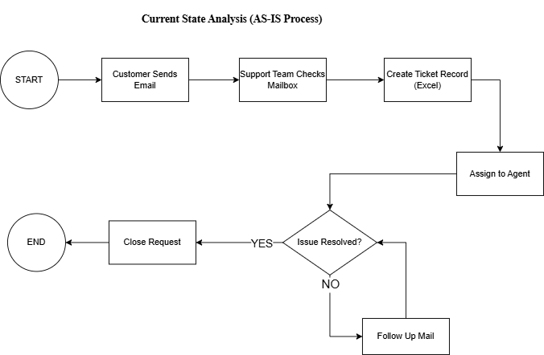
Current State Analysis (AS-IS Process)

The current customer support process relies on email-based communication and manual tracking through Excel. This approach results in limited visibility, delayed responses, and inefficient ticket management.

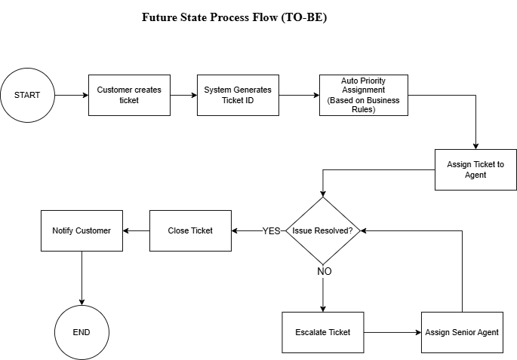
Future State Analysis (TO-BE Process)

The proposed solution introduces a centralized ticket management system with automated ticket creation, priority assignment, tracking, and escalation workflows to improve efficiency and customer satisfaction.
Functional Requirements
- FR-001
System shall allow customer to create ticket.
- FR-002
System shall generate unique Ticket ID.
- FR-003
System shall assign ticket priority.
- FR-004
Support agents shall update ticket status.
- FR-005
System shall send notifications.
- FR-006
Manager shall view ticket dashboard.

